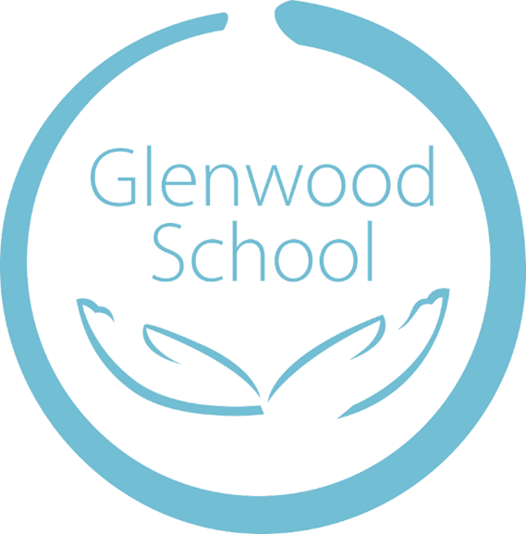

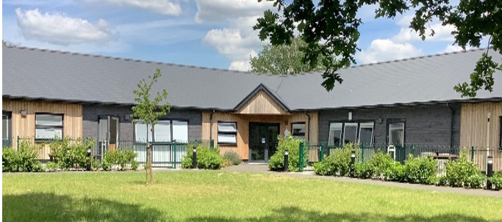

**Welcome**

**o**

**to**

**The Glen**



**This is a guide for all the young people who come to stay at The Glen**

**Hopefully, you will be able to see what your time at The glen might be like as well as getting to know a little about the home, the adults and any other information we feel you might like to know.**

**We are aware it may be your first time staying away from home and we understand that it may also be very scary for you and so we hope to make you feel as comfortable and relaxed as possible. We are here to support you and want to make you feel safe and secure.**

**At The Glen we want to help you make changes at home and at school. We will do this by supporting you to learn new ways of sharing spaces, using different things to help with your communication and learning new skills.**

**The adults will support you to be as independent as possible with your daily routines. At The Glen, adults will help you to feel safe, share spaces with your friends, and give you the opportunity to try new things. We will also help you to work on things you can already do but may find difficult.**

**We will speak with your class teacher, and your family to find out all about you, what you do at home, what’s important to you and most important of all, what you need help with to become more amazing than you already are!**

**The Glen is made up of 2 buildings. House 1 – Elm and Willow and House 2 – Ash and Cedar. You will be staying in ……………….**

**This house has 10 bedrooms – 5 down each corridor. This means you will be staying with other young people. A lot of thought goes into where you stay to allow you to be staying on a corridor with other young people, we feel that you would be able to share spaces with, with support of the adults.**

**You will be able to choose your bedroom and make it feel like your own, whether this is bringing in your favourite blanket, things you like, duvet covers and putting up your own posters.**

**You can bring in your own bedding (or choose one of ours), photos, music, lights or things that you like to use at home.**

**There is a set of drawers and a wardrobe for you to unpack and place your clothes in. Here is an idea of how the bedrooms are set up.**

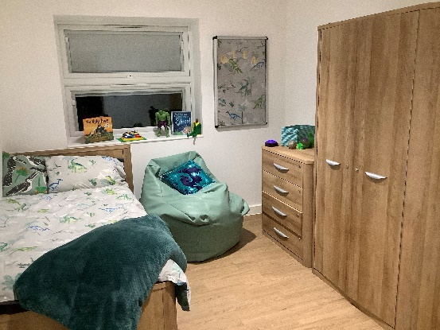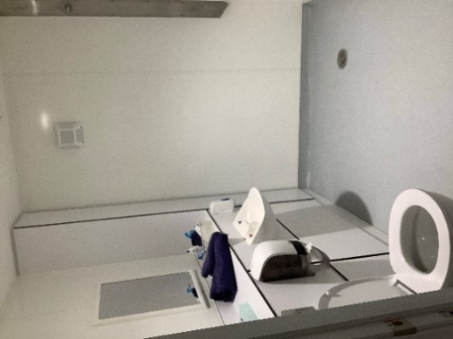

**You will also have your own bathroom that is attached to your bedroom to allow you to use the toilet, wash yourself and brush your teeth in privacy.**

**Your bedroom is your private space to enjoy away from others. We will always knock before entering and if you or other young people would like to enter each other’s bedrooms, you should also knock and ask permission from each other first.**

**The Glen**

Here is an idea of some of the areas of The Glen you will be sharing with the other young people staying –

Shared Spaces

Cloak Room/Entry Lobby

Dining Room – This is where you will be able to eat your food – We try to all eat

together at the same table, however, if this is too difficult for you we can look at supporting you to have a separate space and work your way to eating as a group.

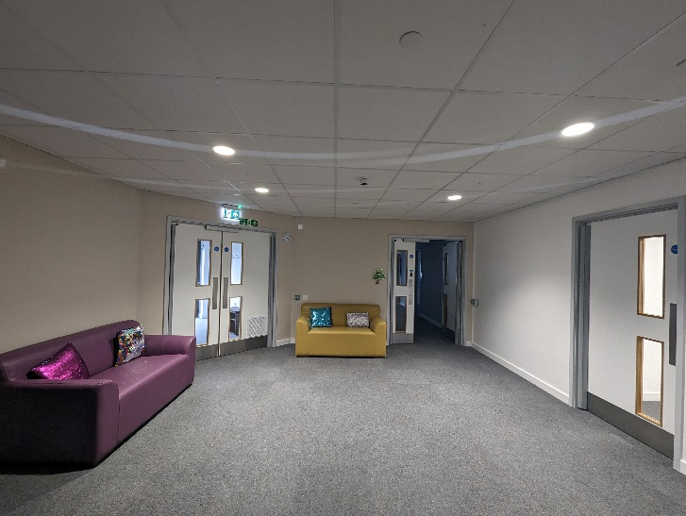

Kitchen – This is where you will be able to prepare your snacks, dinner and drinks.

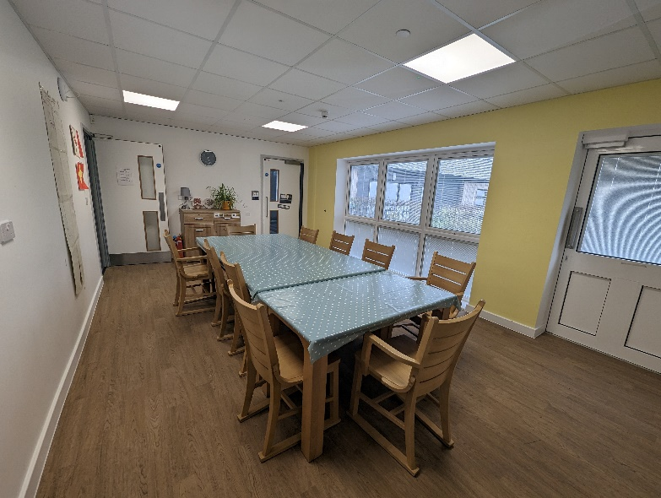

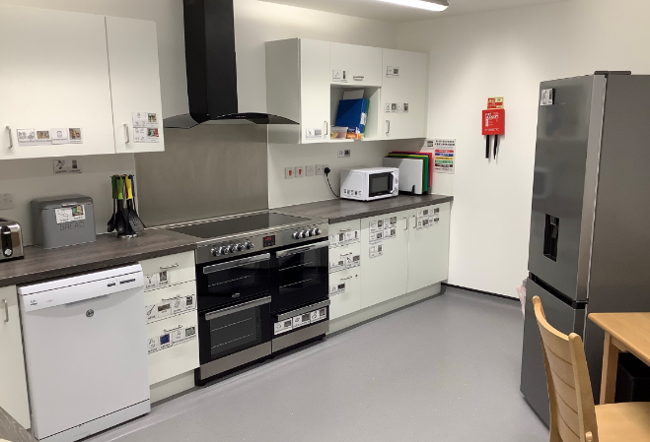

TV Lounge – This is where you can play games and watch television together. You will need to share this space with others so you may not always get to choose what is on the TV. You can bring your own games console and your iPad with you too.

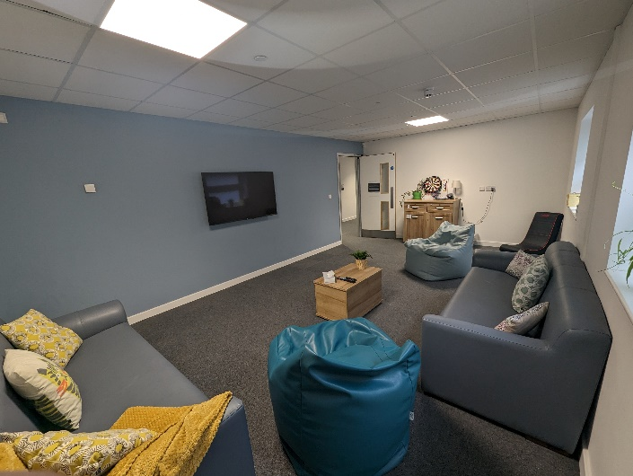

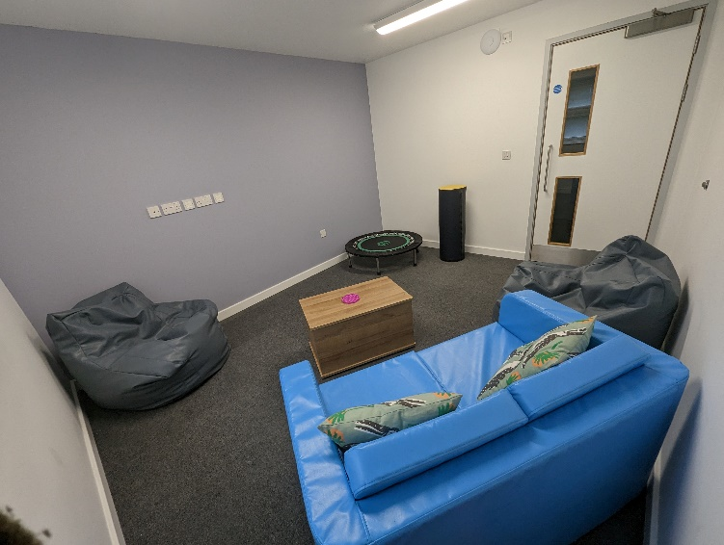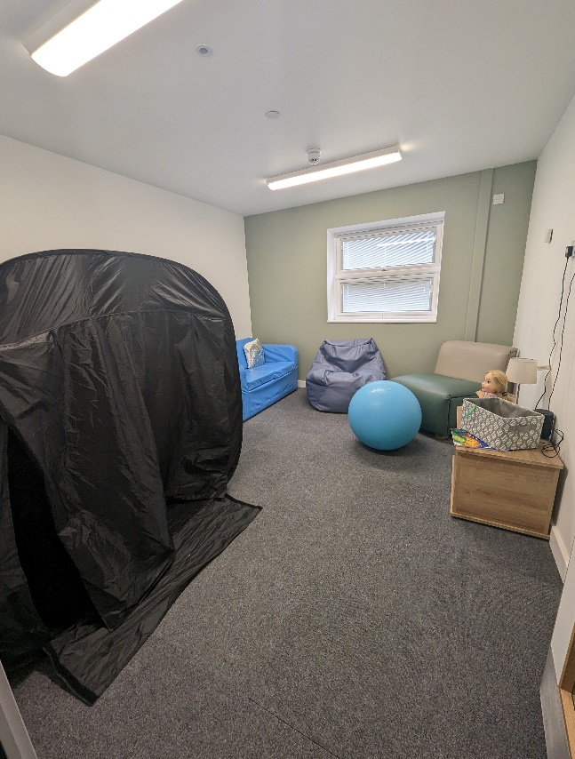

Relaxation Lounge – this lounge has no TV, however, this is a small space to relax in a quiet area away from others if you feel you need a change of scenery.

Laundry Room – This is where you will do your laundry and also choose your bedding if you do not bring your own. The adults will support you with this.

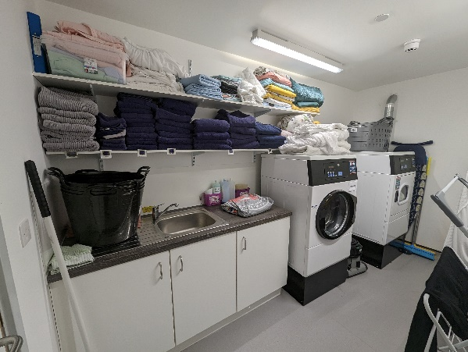

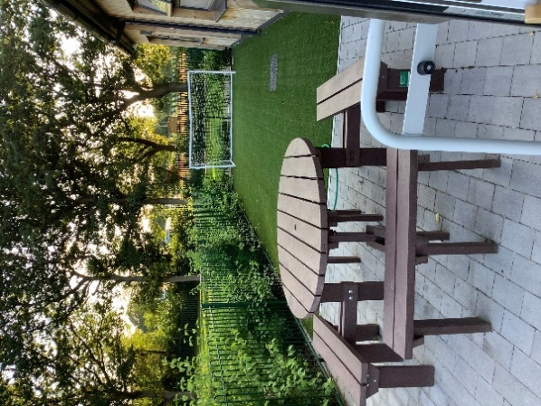Back Garden – When the weather is nice, you will be able to spend time outside in this space. You can either sit and relax or play games and explore nature. Maybe even learn how to grow your own plants or vegetables!

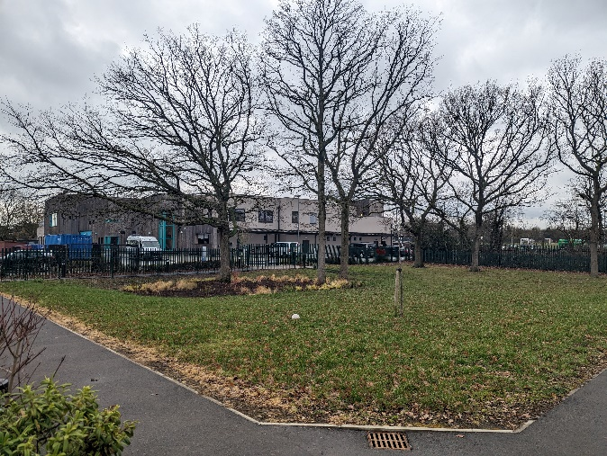

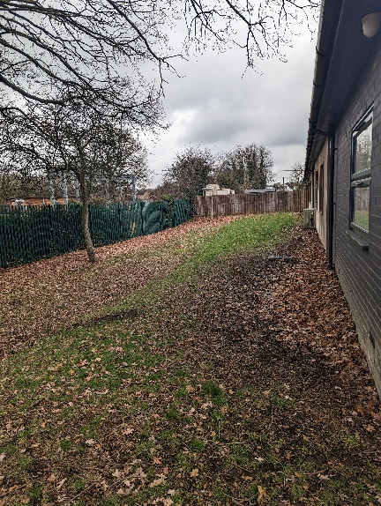

**Whilst staying with us at the Glen, you will have a plan to help support you.**

**Your routine here will depend on what your family has said is right for you. We will work with you to help you to do as much of this on your own as you can.**

**This will help you to have a better understanding of what you need to do each day. Here is a brief idea of what the day-to-day routine may look like:-**

**Routine and Activities**

|  |  |
| --- | --- |
| 07.45 | *Time to get up and ready for the day (shower/wash, dress)* |
| 8:15 | *Breakfast* |
| 8.55 | *Leave for school* |
| 15:00 | *Return to The Glen* |
| 15:15 | *Time to settle, have a snack/drink* |
| 15:30 | *Unstructured time – personalised and group activities* |
| 17:00 | *Teatime* |
| 18:00-20.00 | *Unstructured time – personalised and group activities* |
| 20.00 | *Quiet time, settling activities, getting ready for bed* |
| 21:00 | *Time to sleep* |

**Key Worker**

**How will you know your family is ok?**

The adults will speak to your family to tell them about all the fantastic things you’ve been up to. If at any time you feel sad, or feel that it is important for you to speak to your family you can ask the adults. You can also plan ahead with your family for a facetime if you feel this might help make your stay more comfortable and if you are feeling sad

**Whilst you stay with us, there will be lots of staff around to support your needs. As well as this, you will have a dedicated key worker who will make sure you are getting everything you need. Your key workers will**

* ***Help you learn new life skills***
* ***Support you with the things that you need to learn whilst here at the glen, based on your routines***
* ***Support you with your bedtime routines***
* ***Support you with your communication***
* ***You can approach any adult in the home should you need support, however, your key worker will be around to make sure you are getting everything you need.***



**Health and Safety**

**It is important that all of us, (That’s you, too), keep the home clean and tidy.**

**Staff will do health and safety checks on every room in the house. This is to make sure everything is in working order and you are in a safe space.**

**There are sometimes Fire safety checks in the house, including fire drills to make sure that all the alarms work if there was a fire. When you hear the fire alarm being very noisy, it is important that you leave the house when staff ask you as this could be a real fire!**

**We will also support you with regular cleanliness and hygiene. You will shower daily, and brush your teeth regularly. This is something we can help you with if you are not confident doing this alone just yet.**

**Bullying**

Here at The Glen, we think it is important that you and the rest of the young people treat each other in a kind and caring way. By doing this, you will have a much happier stay as it’s nice to get along. We do not tolerate Bullying at the Glen as it’s not very kind to make someone feel upset or unhappy with not very nice words or actions. Please speak to staff if any of the other young people are unkind to you in any way and we can help you to become friends again.



[www.childline.org.uk](http://www.childline.org.uk)

0800 1111

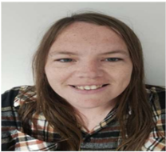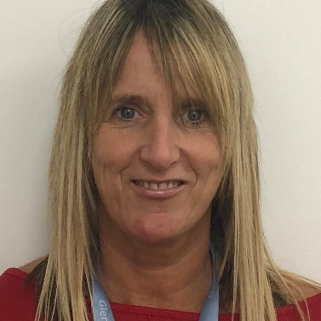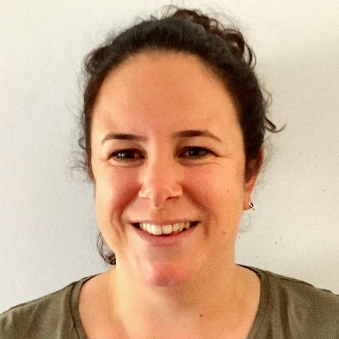

**Senior Support**

**Favourite Animal?**

**Favourite Colour?**

**Senior Support**

**Favourite Animal?**

**Favourite Colour?**

**Sadie:**

**Senior Support**

**Favourite Animal? Alpaca**

**Favourite Colour? Pink**

**Senior Support**

**Favourite Animal?**

**Favourite Colour?**

**Emily**

**Coral**

**Head of Residential Care**

**Favourite Animal? Cats**

**Favourite Colour? Green**

**Head of Educational Care**

**Favourite Animal? Dogs**

**Favourite Colour? Green**

**Laura**

**Kate**

**Staff Team**

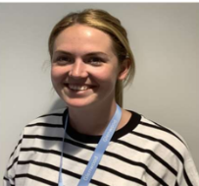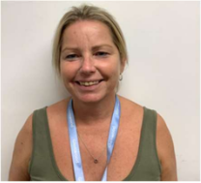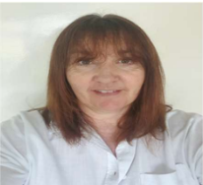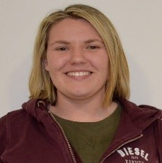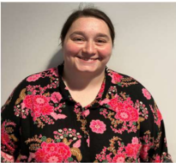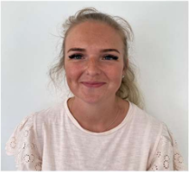

**Residential Support**

**Favourite Animal?**

**Favourite Colour?**

**Lauren**

**Amy**

**Residential Support**

**Favourite Animal?**

**Favourite Colour?**

**Jade**

**Georgina**

**Residential Support**

**Favourite Animal?**

**Favourite Colour?**

**Residential Support**

**Favourite Animal? Pig**

**Favourite Colour? Blue**

**Cara**

**Lynn**

**Residential Support**

**Favourite Animal? Otter**

**Favourite Colour? Grey**

**Residential Support**

**Favourite Animal?**

**Favourite Colour?**

**Residential Support**

**Favourite Animal? Cat**

**Favourite Colour? Sky Blue**

**Erin**

**Residential Support**

**Favourite Animal? Dog**

**Favourite Colour? Cadburys Purple**

**Residential Support**

**Favourite Animal? Turtle**

**Favourite Colour? Turquoise**

**Jenni**

**Kelly**

***This guide will be adapted to all learners that come to the Glen – whether it be in the current format, with staff or parents reading this to their young person, more visual friendly, or even could be adapted via video format, physical touring of the premises or any other way that we at The Glen feel will best get as much of this information over as the young person is able to understand as a way to help the young person gain a better idea of the information within this document.***